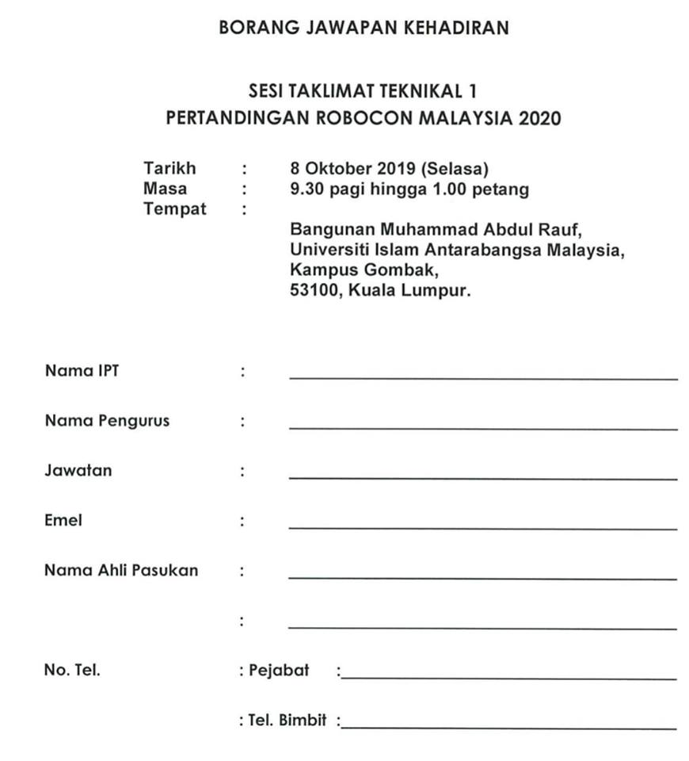

03-64216421

019-6441870

Muhammad Syahmi bin Zulkefli

Muhammad Luqmanul Hakim bin Zulkifli

Iium.robocon@gmail.com

Pensyarah

Assistant Professor Dr Ahmad Imran bin Ibrahim

Universiti Islam Antarabangsa Malaysia

imran@iium.edu.my

Universiti Islam Antarabangsa Malaysia

Pensyarah

Assistant Professor Dr Ahmad Imran bin Ibrahim